**INSTALLATION OF SQUID PROXY ON UBUNTU 22**

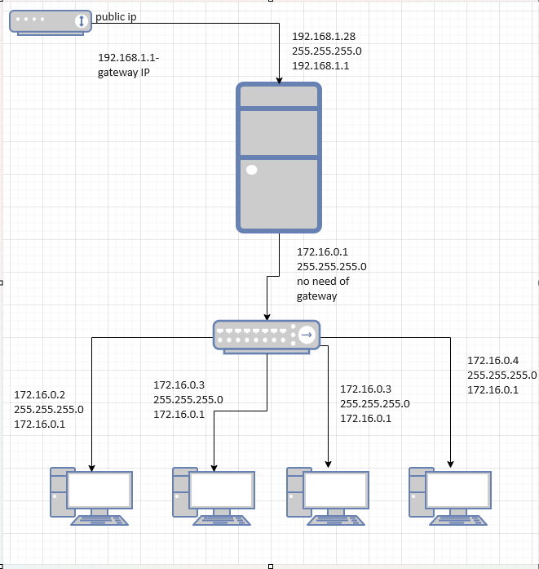

1. sudo apt update
2. sudo apt install squid
3. systemctl status squid.service
4. sudo nano /etc/squid/squid.conf

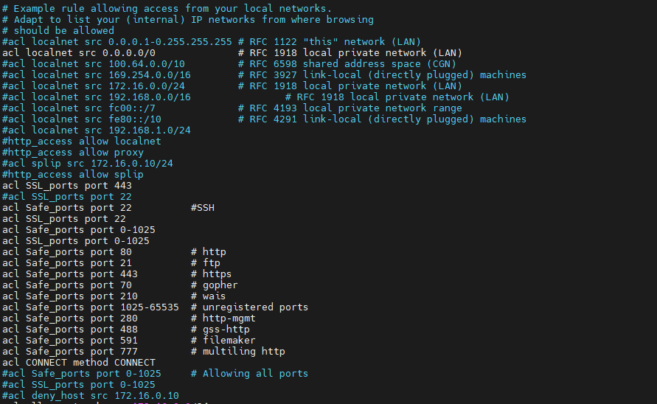

**To deny certain domains for specific user**

acl test src 172.16.0.19

acl block dstdomain "/etc/squid/spldomainblk"

http_access deny test block

http_access allow test

To deny multiple users for accesing multiple domains

For example, create /etc/squid/blockusers and add the IP addresses

172.16.0.19

172.16.0.20

172.16.0.21

Define ACLs for the domains:

For example, create /etc/squid/spldomainblk and add the domains

example.com

anotherexample.com

# Define ACL for blocked users

acl blocked_users src "/etc/squid/blockusers"

# Define ACL for blocked domains

acl blocked_domains dstdomain "/etc/squid/spldomainblk"

# Deny access for blocked users to blocked domains

http_access deny blocked_users blocked_domains

# Allow other access for blocked users

http_access allow blocked_users

# Other necessary ACLs and http_access rules...

# Always allow localhost and other necessary rules

http_access allow localhost

http_access allow all

To Deny certain domains for the whole network

acl allow_network src 172.16.0.0/24

acl web_deny dstdomain "/etc/squid/web_deny"

Need to add the below lines to allow or deny the above specified rules

# Deny, unless rules exist in squid.conf.

http_access allow localhost

#http_access deny deny_host

http_access deny web_deny

http_access allow allow_network

http_access deny all

http_access allow SSL_ports

http_access allow Safe_ports

http_access deny test block

http_access allow test

Restart Squid to apply the changes:

sudo systemctl restart squid

Configuring proxy in Client Side

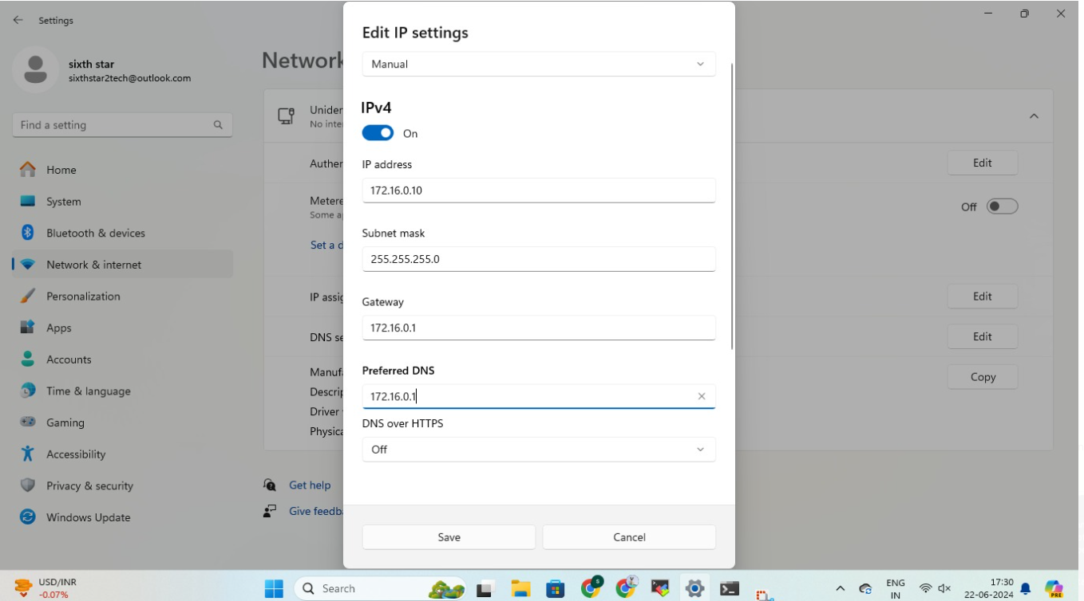

And also we need to set the proxy manually in the client systems

Network settings >> proxy

172.16.0.1

3128

Configuring Proxy in Mobaxterm

